Define a structure for student record and print details

#include <stdio.h>

struct Student {

char name[50];

int roll;

float marks;

};

int main() {

struct Student s1;

printf("Enter name: ");

scanf("%s", s1.name);

printf("Enter roll: ");

scanf("%d", &s1.roll);

printf("Enter marks: ");

scanf("%f", &s1.marks);

printf("\n--- Student Details ---\n");

printf("Name: %s\n", s1.name);

printf("Roll: %d\n", s1.roll);

printf("Marks: %.2f\n", s1.marks);

return 0;

}

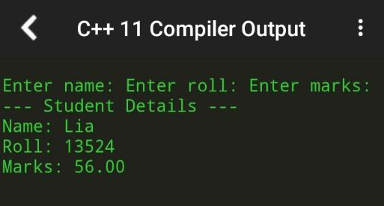

2. Store and display employee details using structures

#include <stdio.h>

struct Employee {

char name[50];

int id;

float salary;

};

int main() {

struct Employee e;

printf("Enter name: ");

scanf("%s", e.name);

printf("Enter ID: ");

scanf("%d", &e.id);

printf("Enter salary: ");

scanf("%f", &e.salary);

printf("\n--- Employee Details ---\n");

printf("Name: %s\n", e.name);

printf("ID: %d\n", e.id);

printf("Salary: %.2f\n", e.salary);

return 0;

}

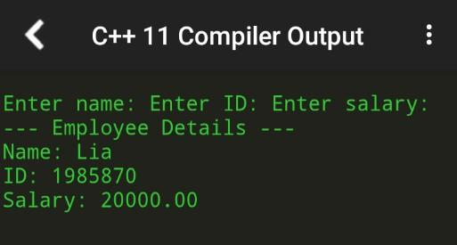

3. Pass a structure to a function

#include <stdio.h>

struct Student {

char name[50];

int roll;

float marks;

};

void display(struct Student s) {

printf("\nName: %s\nRoll: %d\nMarks: %.2f\n", s.name, s.roll, s.marks);

}

int main() {

struct Student s1;

printf("Enter name: ");

scanf("%s", s1.name);

printf("Enter roll: ");

scanf("%d", &s1.roll);

printf("Enter marks: ");

scanf("%f", &s1.marks);

display(s1);

return 0;

}

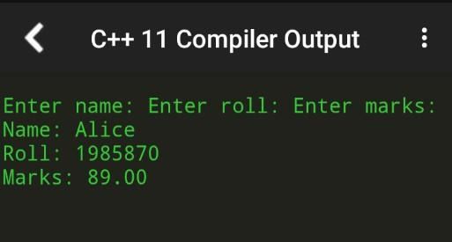

4. Store multiple student records using array of structures

#include <stdio.h>

struct Student {

char name[50];

int roll;

float marks;

};

int main() {

int n;

printf("Enter number of students: ");

scanf("%d", &n);

struct Student students[n];

for (int i = 0; i < n; i++) {

printf("\nEnter name: ");

scanf("%s", students[i].name);

printf("Enter roll: ");

scanf("%d", &students[i].roll);

printf("Enter marks: ");

scanf("%f", &students[i].marks);

}

printf("\n--- Student Records ---\n");

for (int i = 0; i < n; i++) {

printf("%s\t%d\t%.2f\n", students[i].name, students[i].roll, students[i].marks);

}

return 0;

}

5. Demonstrate nested structures

#include <stdio.h>

struct Date {

int day, month, year;

};

struct Student {

char name[50];

int roll;

struct Date dob;

};

int main() {

struct Student s1;

printf("Enter name: ");

scanf("%s", s1.name);

printf("Enter roll: ");

scanf("%d", &s1.roll);

printf("Enter DOB (dd mm yyyy): ");

scanf("%d %d %d", &s1.dob.day, &s1.dob.month, &s1.dob.year);

printf("\nName: %s\nRoll: %d\nDOB: %02d-%02d-%04d\n",

s1.name, s1.roll, s1.dob.day, s1.dob.month, s1.dob.year);

return 0;

}

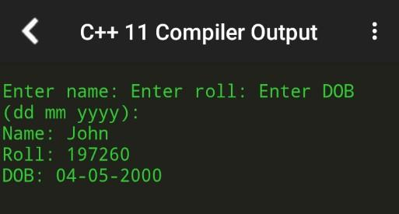

6. Calculate total and average marks using structures

#include <stdio.h>

struct Student {

char name[50];

float marks[3];

};

int main() {

struct Student s;

float total = 0, avg;

printf("Enter name: ");

scanf("%s", s.name);

for (int i = 0; i < 3; i++) {

printf("Enter marks for subject %d: ", i + 1);

scanf("%f", &s.marks[i]);

total += s.marks[i];

}

avg = total / 3;

printf("\nName: %s\nTotal: %.2f\nAverage: %.2f\n", s.name, total, avg);

return 0;

}

